Case 5-Asia-China-Qijia-Cong-8 Tier-Black Jade-height 1.8 in.

height 1.8 in., width 1.2 x1.2 in., weight 112 gm.

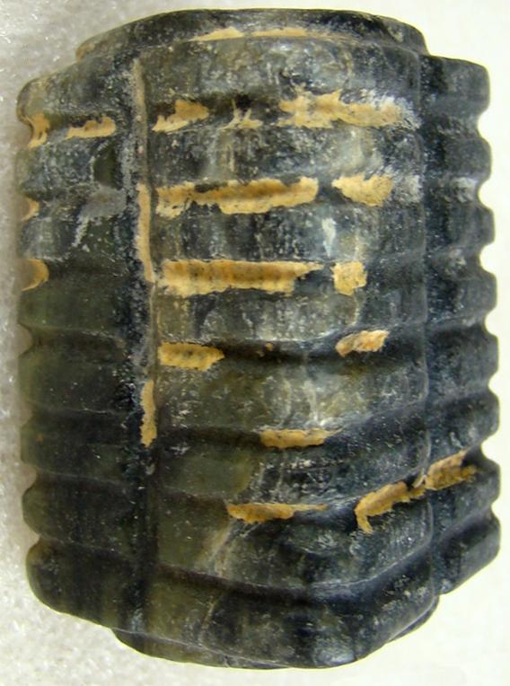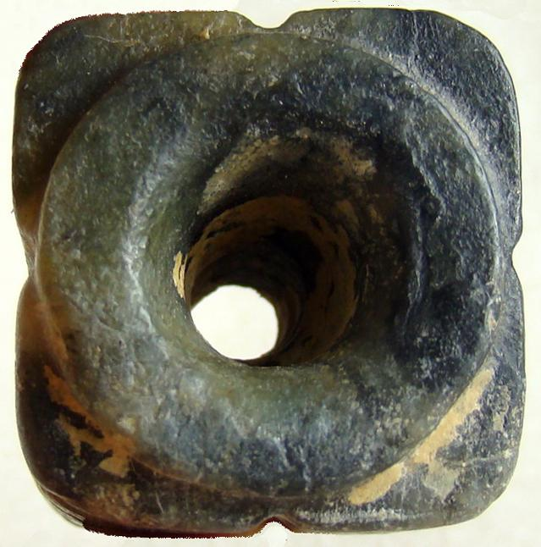

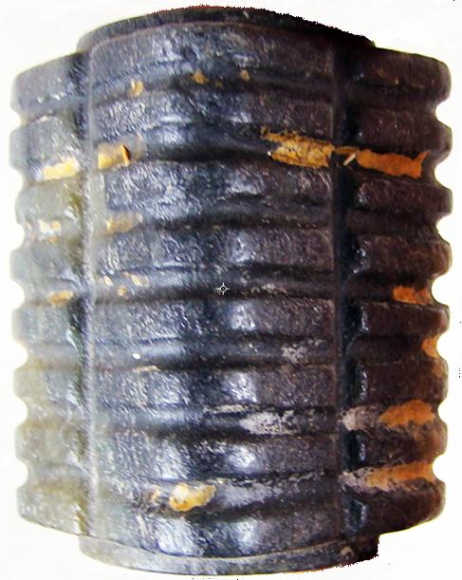 SHAPE \\* MERGEFORMAT 

